SPSS solutions but need work and answers to match in Excel format

1. Use the Productivity data set. Examine the bivariate relationship between having authority (Jobauthr) and knowledge (Jobknowl) to do one’s job. What are your findings? Use simple regression.
Ans: This exercise challenges students to identify the dependent and independent variable. In the following analysis, we use Jobauthr as the dependent variable. Arguably, the relationship between these two variables might be viewed as only an association.
Model Summary
Model | R | R² | Adjusted R² | SEE
1 | .141ª | .020 | .017 | 1.22051
ªPredictors: (constant), knowledge to perform job responsibilities
ANOVAª
Model |  | Sum of Squares | df | Mean Square | F | Significance
1 | Regression  Residual  Total | 9.689  475.198  484.887 | 1  319  320 | 9.689  1.490 | 6.505 | .011^{b}
ªDependent variable: extent to employee has authority to make decisions while performing job
^{b}Predictors: (constant), knowledge to perform job responsibilities

Coefficientsª
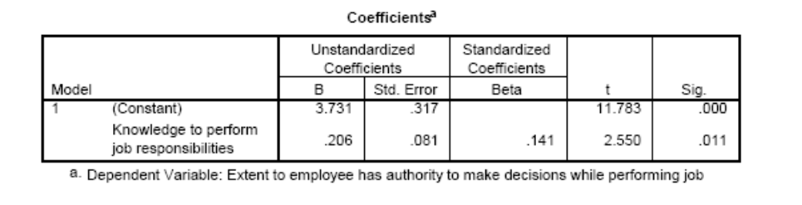
a. Dependent variable: extent to employee has authority to make decisions while performing job
2. Use the Productivity data set. Examine the bivariate relationship between employees’ perception of productivity and the perceptions of having adequate authority to do one’s job (Jobauthr). Use both simple regression and Pearson’s correlation coefficient.

Ans: Using Pearson’s correlation coefficient, we find that r = .369 (p < .01). The output from the simple regression is:
Model Summary
Model | R | R² | Adjusted R² | SEE
1 | .369ª | .136 | .133 | .79649

ªPredictors: (constant), extent to employee has authority to make decisions while performing job
ANOVAª
Model |  | Sum of Squares | df | Mean Square | F | Significance
1 | Regression  Residual  Total | 31.845  202.374  234.219 | 1  319  320 | 31  .845  .634 | 50  .197 | .000b
ªDependent variable: Employee evaluation of workcenter productivity
^{b}Predictors: (constant), Extent to employee has authority to make decisions while performing job

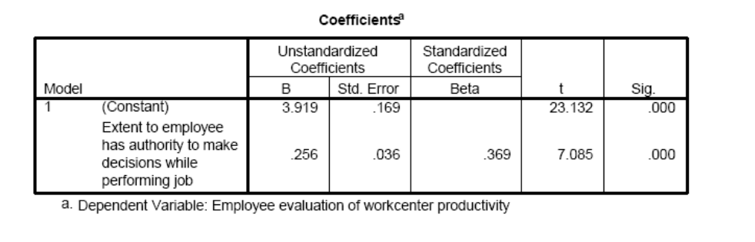

Correlations
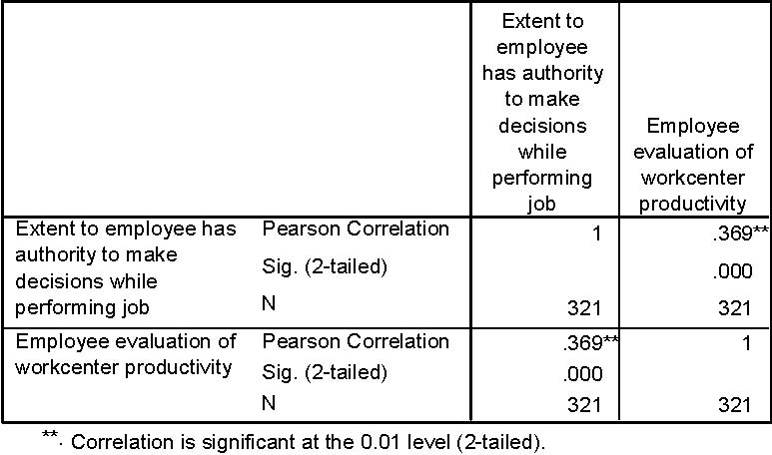

3. Many managers believe that a government’s spending on the environment is a response to the environmental pressure such as population growth, pollution level, and economic development. (1) Use the data set Data_FL_County to conduct a hypothesis test on the relationship between the environmental spending (EnvirnTotal08) and population growth (PopGrowth08) using the Pearson correlation. (2) Run a simple regression for this relationship.
Ans: Note: environmental spending (EnvirnTotal08) is a ratio of environmental spending/total spending.

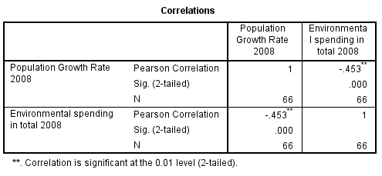

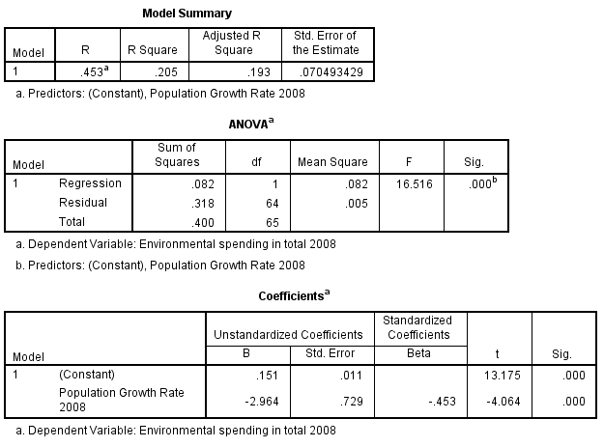

4. Use the Public Perceptions data set. Examine a multiple regression model in which the dependent variable is Posview (“I have a positive view of Orange County”). The independent variables are Quality (“The quality of life in Orange County is good”), Interest (“I believe that the county is interested in what I have to say”), Respect (“The employees treated me with courtesy and respect”), Trust (“Do you trust Orange County to do what is right most of the time?”), and Works (“Do you believe that Orange County works efficiently?”). Examine the error term plot and write up your findings.
Ans: The following results are produced, when running the model on the subset of respondents who have had contact with the county employees during the last 12 months (i.e., when contact = 1. Substantively, the results for running the model for all respondents are not much different):
Model
R | R² | Adjusted-R² | SEE
.654 | .427 | .421 | .460

Dependent variable: “I have a positive view of Orange County”
ANOVA Table
Model | Sum of Squares | df | Mean Square | F | Significance
Regression | 70.225 | 5 | 14.045 | 66.943 | .000
Residual | 94.202 | 449 | .210
Total | 164.426 | 454

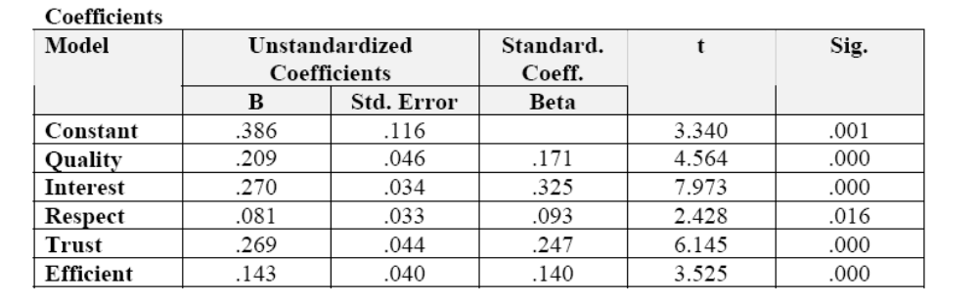
The above results show that all variables are significant. However, the pattern of error terms is not random. There are clear bands of downward sloping error terms. The bands are caused by the dependent variable, which has only four categories (indeed, one could argue against using this variable as a dependent variable . . . ). The downward sloping pattern is discussed in Chapter 14 as measurement error. For the purposes of this exercise, it is sufficient to note that the pattern of nonrandom error terms is a violation that requires further investigation.

